Lincoln High School
Thursday, May 26th, 2022

CAMPUS ACTIVITIES
Day/Date | Event | Place | Time

Link Crew
Link Crew list is posted on the Student Activities Window. Stop by and check it out.

Are you interested in a 2-week residential, all inclusive program at UOP? The University of Pacific is offering a summer program that offer students learning environments focused on cutting-edge topics and hands-on experiences in their labs, studios, fields, and makerspaces. The program runs from June 19th - July 1st. If you are interested in this program, please see Ms. Barbieri in the Student Service Center.

Color Guard - Come join us for some color-guard clinics in the band room (1200). On June 9th, 14th and 16th. 6-8pm all days. With auditions on 6/21. For additional information you can contact Julia Cornejo at Juliacornejo3@gmail.com See you there.

AP Summer Homework, Google Classrooms, and Textbook Info: if you are taking an AP class next year, please click on this document and make sure you have checked out any textbooks you need by Wednesday, May 25. The library will be closed for the summer. AP SUMMER 2022 HOMEWORK AND TEXTBOOKS

Yearbooks: Yearbooks have officially sold out. We have a waiting list started for what is available after distribution. We will not know how many until the shipment arrives. Please fill out this link as soon as possible if you are interested in one of the extra books (https://forms.gle/jjocUM5ohSPppk6X6 ). It is also available on our website.
Yearbook distribution will now be on Monday from 4-7 under the shade tree across from the stadium.

SENIORS! SENIORS!

- Click here to migrate your files, emails and contacts before your email is no longer available.
Migrate Instructions

Lost your ID? - If you have lost your ID and need a replacement, come to the Student Service Center to obtain a new school ID.

TECHNOLOGY HELP - Please call 209-953-8984 to help with Chromebook and Technology issues

Lincoln Athletics

CLICK HERE FOR LINCOLN ATHLETIC WEBSITE

Click here for updated counselor information

Here is the link to your Counselor’s email address: https://sites.google.com/lusd.net/lhscounseling/meet-your-counselor?authuser=0

COLLEGE AND CAREER CENTER
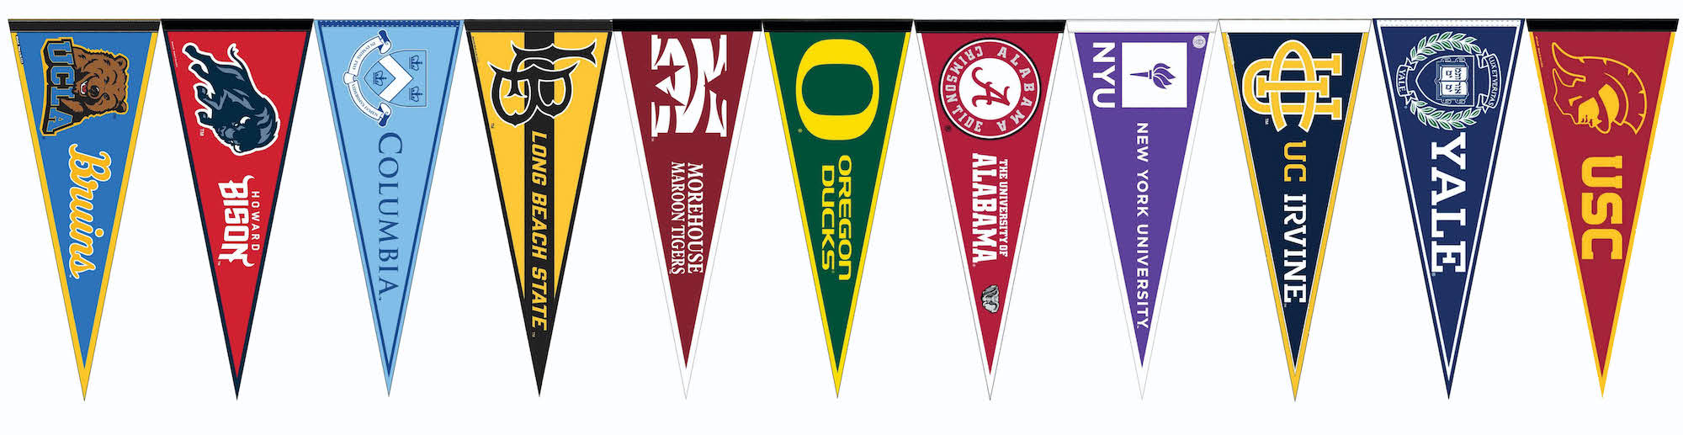
Click here for up to date information

QUICK LINKS
USB WEBSITE (Formerly ASB) | Video Announcements, club news, trustee reports, etc.
BELL SCHEDULE | Bell Schedule, Grading/Progress Dates.
COLLEGE AND CAREER CENTER | Find out about scholarships, workshops and career opportunities here.
COMMITMENT TO COMMUNITY | Commitment 2 Community Award gives special recognition to students who document 100 volunteer hours each year. Visit the Commitment 2 Community website for more information on the program.
COUNSELOR’S HOURS: CHECK BACK SOON! | All students are encouraged to email their counselor directly if they need immediate support and/or have questions and/or concerns. Counselors are available to set up individual appointments with any student who requests one at any time.
COVID Self-Check | Check this form for COVID symptoms. If you answer yes to any of these questions, keep your student home.
LINCOLNIAN | The Lincoln High School newspaper, The Lincolnian, is now online. The paper is produced entirely by students in Mr. Sperisen’s journalism class.
DISNEYLAND GRAD NITE 2022 | Trip information and guidelines.
EVERYTHING GRADUATION | Stay up to date on everything graduation related here! Current information includes Jostens cap and gown ordering and diploma details.
SCHOOL CALENDARS | 2021-22 and 2022-23 Calendars are posted on the district website: www.lusd.net
SENIOR 2022 ANNOUNCEMENTS | Pertinent info and save the dates for 2022 Seniors
SPIRITWEAR | Purchase LHS Spirit Wear here
TROJAN WELLNESS SITE | Students, parents and staff
TUTORING SCHEDULE | Please share schedules with students that are in need.
WORK PERMIT | Work permit procedures and application.
YEARBOOK INFO | Click the link to the left.

